Blinkit
-- Avg Rating
SELECT ROUND(AVG(rating), 2) AS avg_rating FROM retail_sales;
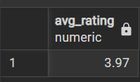
-- Avg Sales
SELECT ROUND(AVG(sales), 2) AS avg_sales FROM retail_sales;
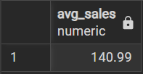
-- No. of Items
SELECT COUNT(*) AS no_of_items FROM retail_sales;
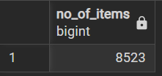

-- Total Sales
SELECT ROUND(SUM(sales), 2) AS total_sales FROM retail_sales;
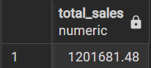
-- Filter checked
SELECT ROUND(AVG(sales), 2) AS avg_sales
FROM retail_sales
where item_type = 'Dairy'
and outlet_location_type = 'Tier 1'
and outlet_size = 'Medium';
